Web Search #1 – Front Page at http://tclauset.org

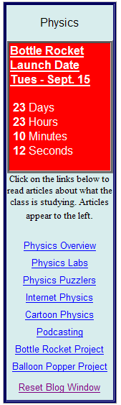
Name ___________________________________________________ Date _____________ Class Period _____________

Use the links shown in the graphic to access the particular web pages that will show up inside the blog window. Read the question first, search the article, and write down your answer in the blank provided. There are 20 questions. Each answer is worth 5 points. Don’t cheat and get the answers from a friend. You need to do this YOURSELF so you will learn your way around the science web site!

1. Physics Overview: The article names three types of word problems for which there are practice tests on the study guides web page. Name these three types of word problems:
1) __________________ 2) _________________ 3) _____________________

2. Physics Labs: Which lab talks about learning how to lift a 5,000 lb car? __________________

3. Physics Puzzlers: In puzzler #3 the most important word in the entire puzzler describes something the airplane is doing. It is the 4th word from the start of the 4th sentence. What is the word? __________________________

4. Internet Physics: In the Newton’s Cannon java applet, what is the minimum speed in miles/hr for the cannon ball in order for it to circle the earth and return to it’s starting point? (Note: You will hear the “Ouch” sound if it successfully returns to its starting point.) __________________

5. Cartoon Physics: What is the cartoon law involving anvils? _________________________
_____________________________________________________________________________

6. Podcasting: What 2 pieces of equipment will we use in recording our podcasts ?

a) _______________________________ b) ________________________

7. Bottle Rocket Project: What are the last three concepts listed in the article?
a) ______________________ b) ___________________ c) __________________

8. Balloon Popper Project: From the article’s first paragraph, name the six simple machines:

a) ___________ b) _____________ c) ________________ d) ______________ e) ____________ f) ______________

9. Reset Blog Window (Google Earth Moon Tour article): What was the name of the mission in which astronauts first landed on the moon? ____________________________.

10. Reset Blog Window (Google Earth Moon Tour article): What version of Google Earth do you need in order to view the videos and pictures of the moon landing 40 years ago? ___________________

